**LIBRARY MANAGEMENT SYSTEM**



This Report Presented in Partial Fulfillment of the Requirements for the Degree of Bachelor of Science in Computer Science and Information Technology

**Supervised by: Shiva Om Dahal**



**Department of Computer Science & Information Technology**

**Faculty of Computer Science and Information Technology**

**Submitted by: Submitted to:**

Name: Anjana Khatri Shiva Om Dahal

Symbol: 24439/076 Department of CSIT

Name: Bimesh Shrestha Banepa Nist College

Symbol: 24440/076

Name: Samjhana Shrestha

Symbol: 24455/076

**Abstract:**

Online Library Management System is a system which maintains the information about the books present in the library, their authors, the members of library to whom books are issued, library staff and all. This is very difficult to organize manually. Maintenance of all this information manually is a very complex task. Owing to the advancement of technology, organization of an Online Library becomes much simple. The Online Library Management has been designed to computerize and automate the operations performed over the information about the members, book issues and returns and all other operations. This computerization of library helps in many instances of its maintenances. It reduces the workload of management as most of the manual work done is reduced.

**Acknowledgement:**

This satisfaction that accompanies that the successful completion of any task would be incomplete without the mention of people whose ceaseless cooperation made it possible, whose constant guidance and encouragement crowns all efforts with success.

We are grateful to our teacher **Shiva Om Dahal** for this opportunity, guidance, inspiration and constructive suggestions that helped us in the preparation of this project.

.

**Table of content:**

1. Introduction

1.1 Problem Statement

1.2 Objectives

1.3 Scope

2. Project management

2.1 Project Planning & Scheduling:

2.2 Existing System:

2.3 Proposed System:

3. Feasibility Study

3.1 Technical Feasibility:

3.2 Operational Feasibility:

3.3 Economic Feasibility:

3.4 Management Feasibility:

3.5 Social Feasibility:

4. System Design

4.1 Program Coding

4.2 Development Model

5. Analysis Modeling & Design Methodologies

6. E-R Diagram of Library Management System

7. Data flow Diagram

8. Implementation,Testing & Result

8.1 Implementation

9. Unit Testing

10. Integration testing

11. Conclusion

12. References

## Introduction

Online Library Management System is an [Automated Library System](http://www.edigitallibrary.com/library-automation.html) that handles the various functions of the library. It provides a complete solution to the library management software. The online Library Management System is classified into two parts Bar Code System and RFID System.

Library plays an important role in all schools and colleges, no educational institution can exist without Library Administration Software. It is an important part of every school and college and it helps the librarian to keep records of available books as well as issued books. Library Management System software helps in different ways by providing students the facility to learn, gather resources, promote group learning and improve knowledge and skills.

1.1 Problem Statement

A library database system is an infrastructure that allows users to search books and book content, add/remove, and download selected books. The problem faced is that library users require an efficient method to find a specific book or keyword(s) within a book given a continuously expanding library.

Some other problems are:

Lack of security, lack of data storage, lack of information, slow retrieval of data, misplaced library cards, time consuming, issuing of book is slow, lost books etc

* 1. Objectives
* To collect, organize & collate print & digital information & disseminate at the point of care and for future use.
* To provide seamless access to information
* To act as gateway to digital and electronic information
* To develop in to a single access point library.
* To create and update a comprehensive database of Indian Literature in the field of cancer.
* To develop and conduct tutorials for the users to enable them to effectively utilize the facilities and resources made available by the library.
  1. Scope

The circulation module of an online library management system helps librarians track, manage and report the activities of library users. They no longer have to manually enter data about who borrowed a book or returned one.

The different areas where we can use this application are :

Any education institute can make use of it for providing information about author, content of the available books. It can be used in offices and modifications can be easily done according to requirements.

## 

## Project management

2.1 Project Planning & Scheduling:

Project planning is part of project management, which relates to the use of schedules such as Gantt charts to plan and subsequently report progress within the project environment. Initially, the project scope is defined and the appropriate methods for completing the project are determined. Following this step, the durations for the various tasks necessary to complete the work are listed and grouped into a work breakdown structure. The logical dependencies between tasks are defined using an activity network diagram that enables identification of the critical path.

2.2 Existing System

Early days Libraries are managed manually. It required lot of time to record or to retrieve the details. The employees who have to record the details must perform their job very carefully. Even a small mistake would create a lot of problems. Security of information is very less. Report generations of all the information is very tough task. Maintenance of Library catalogue and arrangement of the books to the catalogue is very complex task. In addition to its maintenance of member details, issue dates and return dates etc. manually is a complex task. All the operations must be performed in perfect manner for the maintenance of the library without any degradation which may finally result in the failure of the entire system.

2.3 Proposed System

To solve the inconveniences as mentioned in the existing system, an **Online Library** is proposed. The proposed system contains the following features:

* The students will register them through Online
* Individually each member will have his account through which he can access the information he needs.
* Book details like authors, number of copies totally maintained by library, present available number of books, reference books, non-reference books etc. all this information can be made handy.
* Regarding the members designation, number of books was issued.
* Issue dates and returns of each member is maintained separately and fine charged if there is any delay in returning the book.
* Administrator can add, update the books.
* Time consuming is low, gives accurate results, reliability can be improved with the help of security.
* Existing system does not have any facility of teachers login or student login where as proposed system will have a facility of student login as well as teacher’s login
* Existing system does not have a facility of online reservation of books whereas proposed system has a facility of online reservation of books
* Existing system does not have any facility to generate student reports as well book issue reports whereas proposed system provides librarian with a tool to generate reports

## 3. Feasibility Study

3.1 Technical Feasibility: This is concerned with specifying equipment and software that will successfully satisfy the user requirement; the technical needs of the system may vary considerably, but might include:

The facility to produce outputs in a given time:

* Response time under conditions.
* Ability to process a certain volume of transaction at a particular seep.
* Facility to communicate data to distant location

3.2 Operational Feasibility: It is mainly related to human organization and political aspects. The points to be considered are:

What changes will be brought with the system?

What organizational structures are distributed?

What new skills will be required? Do the existing staff members have these skills? If not, can then the trained due course of time

3.3 Economic Feasibility**:** Economic analysis is the most frequently used technique for evaluating the effectiveness of a proposed system. More frequently known as cost/benefit system and compare them with costs. If benefits outweigh costs, a decision is taken to design and implement the system.

3.4 Management Feasibility**:** It is a determination of whether a proposed project will be acceptable to management. If does not accept a project of gives a negligible support to it; the analyst will tend to view the project as a no feasible one.

3.5 Social Feasibility: Social feasibility is a determination of whether the project will be acceptable to the people or not. This determination typically examines the probability of the project accepted by the group directly affected by the proposed system change.

## 4. System Design

Systems design is an interdisciplinary engineering activity that enables the realization of successful systems. A system may be deemed as an integrated set of components that accomplish a defined objective.

### 

### 4.1 Program Coding

Certainly, the graphical user interface (GUI) control and menus cannot work or function especially with the database without a series of codes working behind the scene, or at the background. Therefore, PHP and JavaScript codes relevant to make each control and menu workable can be written to activate their functionalities. Compilation is the final phase of system development of any newly built system, whereby all the final codes are compiled into an executable file and also deployed in a form that can have maximum security self-dependent.

### 4.2 Development Model

It is important to have a proper development model for a workable computerized Library Management System. Thus, to achieve this objective, a waterfall model of software development process which is a classical software model initiated by Winston Royce in 1970 will be deployed to develop this system. This is because it is characterized with linear or sequential execution of the various phases of the software development life cycle as presented in figure 3.1.

It supports proper documentation of each phase, discourages phase skipping and permits testing. Furthermore, it is iterative and permits systematic revisit of previous phases which is a good feature for system improvement.

Thus, the system to be studied will take the following phases:



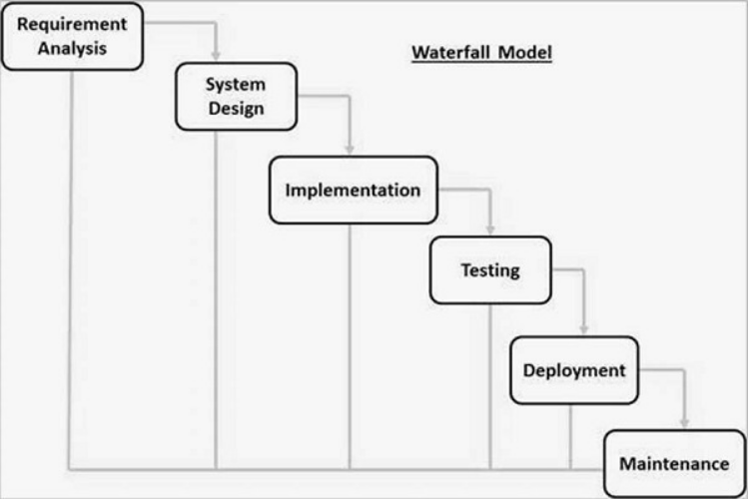



**Figure 3.1:** Waterfall model

## 

## 5. Analysis Modeling & Design Methodologies

The goal will be achieved by studying and going through several database systems that have already been created or are inline of being created.In this phase, I’m going to convert the design of proposed system to computer software, which includes computer programming using phpMyAdmin as a software tool written in PHP, intended to handle the administration of MySQL, and translating the design specifications into the computer code.

## 6. E-R Diagram of Library Management System

An entity-relationship diagram (ERD) is an abstract and conceptual representation of data. Entity relationship modeling is a database modeling method, used to produce a type of conceptual schema or semantic data model of a system, often a relational database, and its requirements in a top-down fashion.

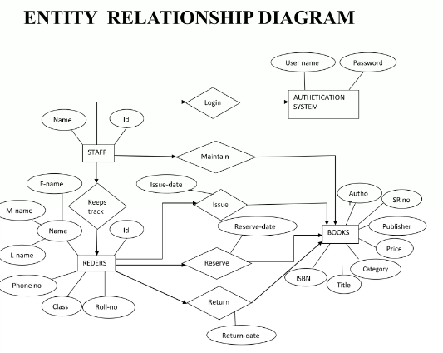

**Figure:** Entity Relationship Diagram

## 7. Data flow Diagram

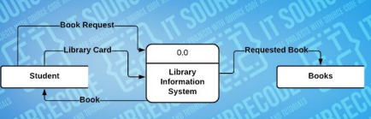

Fig. level 0 DFD

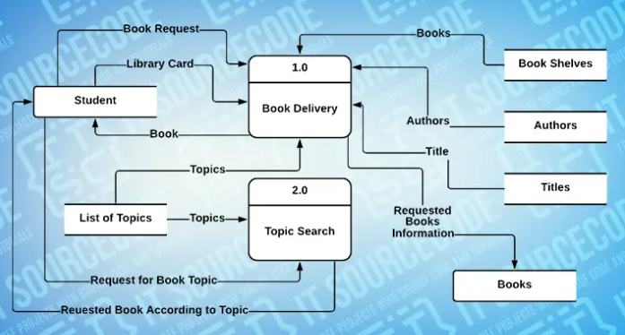

Fig: level 1 DFD

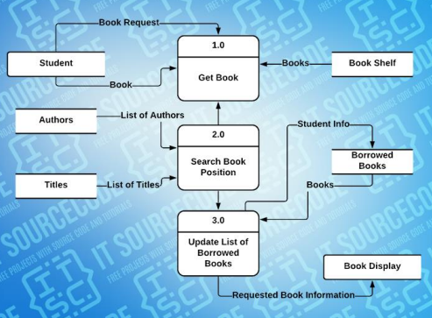

Fig:level 2 DFD

## 8. Implementation, Testing & Result

8.1 Implementation

Since the research is done and building of the project completed, the results show that the website runs smoothly as activities that were originally expected of it to do run properly without errors. These include logging in and out, adding/saving donors information, updating it, deleting it, clear information, searching, alerting admin and viewing the inform. The system also designed inputs the information/data into the database system that is the XAMPP server. The programming languages used when creating this project were SQL for the database system, HTML5 and PHP for designing the pages for logging in and out as well as the page for designing the database page. JavaScript was used to make the website more interactive and user friendly.

After a complete implementation we had successfully tested it onto the website in NetBeans IDE 8.0.2 successful where I used to test the website using chrome default browser.

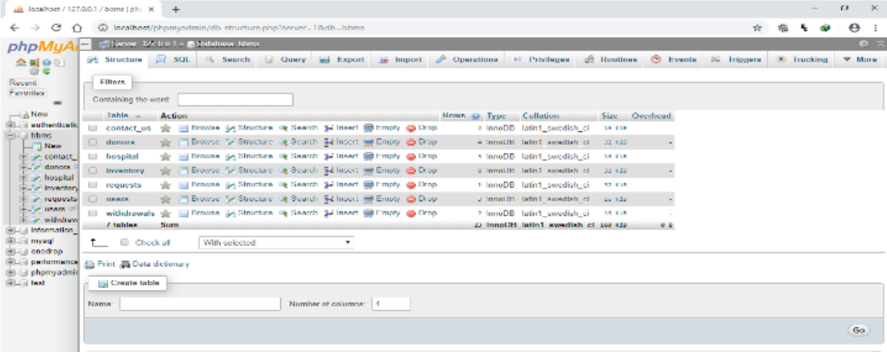  
 *Fig: Database table of library management system*

## 9. Unit testing

Unit testing is undertaken when a module has been created and successfully reviewed .In order to test a single module we need to provide a complete environment, besides the module we would require

⦁ Procedure belonging to other modules that the module under test calls

⦁ Non local data structures that module accesses

⦁ Procedure to call the functions of the module under test with appropriate parameters

Unit testing was done on each and every module that is described under module:

1. Test For the admin module

Testing admin login form-This form is used for log in of administrator of the system. In this we enter the username and password if both are correct administration page will open otherwise if any of data is wrong it will get redirected back to the login page and again ask for username and password

* Student account addition- In this section the admin can verify student details from student academic info and then only add student details to main library database it contains add and delete buttons if user click add button data will be added to student database and if he clicks delete button the student data will be deleted
* Book Addition- Admin can enter details of book and can add the details to the main book table also he can view the books requests.

1. Test for Student login module

* Test for Student login Form-This form is used for log in of Student .In this we enter the library-id, username and password if all these are correct student login page will open otherwise if any of data is wrong it will get redirected back to the login page and again ask for library-id, username and password.
* Test for account creation- This form is used for new account creation when student does not fill the form completely it asks again to fill the whole form when he fill the form fully it gets redirected to page which show waiting for conformation message as his data will be only added by administrator after verification.

1. Test for teacher login module-

* Test for teacher login form- This form is used for log in of teacher .In this we enter the username and password if all these are correct teacher login page will open otherwise if any of data is wrong it will get redirected back to the login page and again ask for username and password.

## 10. Integration testing

In this type of testing we test various integration of the project module by providing the input.The primary objective is to test the module interfaces in order to ensure that no errors are occurring when one module invokes the other module.

## 11. Conclusion

This website provides a computerized version of library management system which will benefit the students as well as the staff of the library.

It makes entire process online where student can search book, staff can generate reports and do book transactions. It also has a facility for student login where student can login and can see status of books issued as well request for book or give some suggestions. It has a facility of teacher’s login where teachers can add lectures notes and also give necessary suggestion to library and also add info about workshops or events happening in our college or nearby college in the online notice board.

**12. References**

## http://www.w3schools.com/html/html_intro.asp

## 

## http://www.Udemy.com/css/css_background.asp

## 

## http://www.w3schools.com/js/js_datatypes.asp